End to End Real Time e-commerce Data Engineering pipeline

Tool and Platform used
Cloud : Azure Eventhub, Azure Databricks

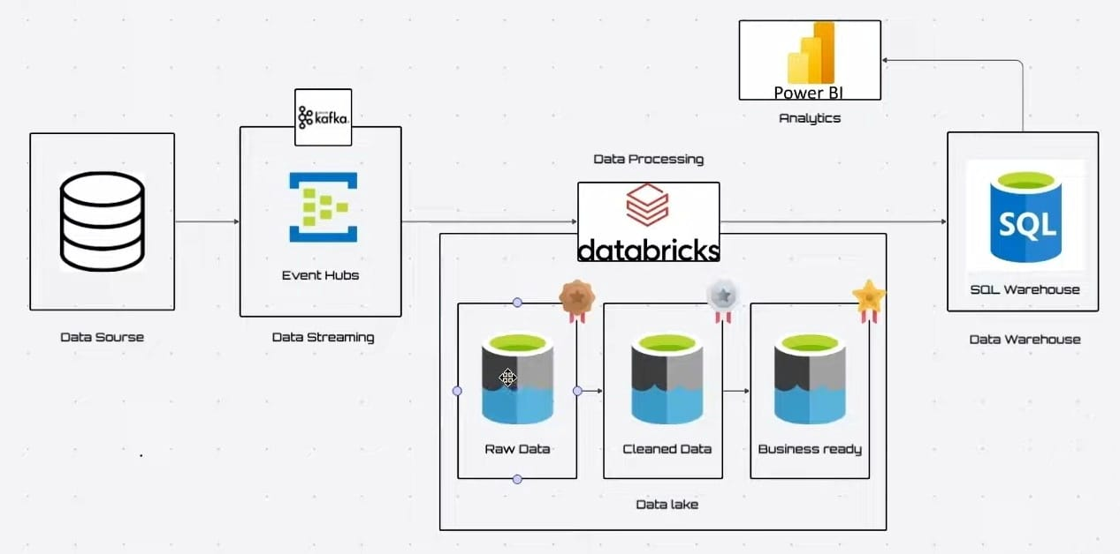

Phase 1
- Create streaming Source
Install required libraries:
Pip install kafka-python
Pip install faker

e-com order data generate
generate_order.py

import json
import random
import time
from datetime import datetime
from faker import Faker

fake = Faker()

categories = ['Electronics', 'Books', 'Clothing', 'Home Decor', 'Toys']
locations = [
{"city": "New Delhi", "state": "DL", "lat": 28.7041, "lon": 77.1025},
{"city": "Mumbai Angeles", "state": "MU", "lat": 18.9582, "lon": 72.8321},
{"city": "Pune", "state": "PN", "lat": 18.5246, "lon": 73.8786},
{"city": "Bengaluru", "state": "BR", "lat": 12.9629, "lon": 77.5775},
{"city": "Kolkata", "state": "AZ", "lat": 22.5744, "lon": 88.3629}
]

def generate_order():
location = random.choice(locations)
category = random.choice(categories)
price = round(random.uniform(10, 2000), 2)
quantity = random.randint(1, 5)

return {
"order_id": fake.uuid4(),
"timestamp": datetime.utcnow().isoformat(),
"customer_id": fake.uuid4(),
"product_id": fake.uuid4(),
"category": category,
"price": price,
"quantity": quantity,
"total_amount": round(price * quantity, 2),
"city": location["city"],
"state": location["state"],
"country": "USA",
"latitude": location["lat"],
"longitude": location["lon"],
"delivery_status": random.choice(["Processing", "Shipped", "Delivered", "Cancelled"])
}

if __name__ == "__main__":
while True:
event = generate_order()
print("Sent:", event)
time.sleep(2)

- Ingest data into eventhub

Create eventhub service in Azure
- Create Namespace
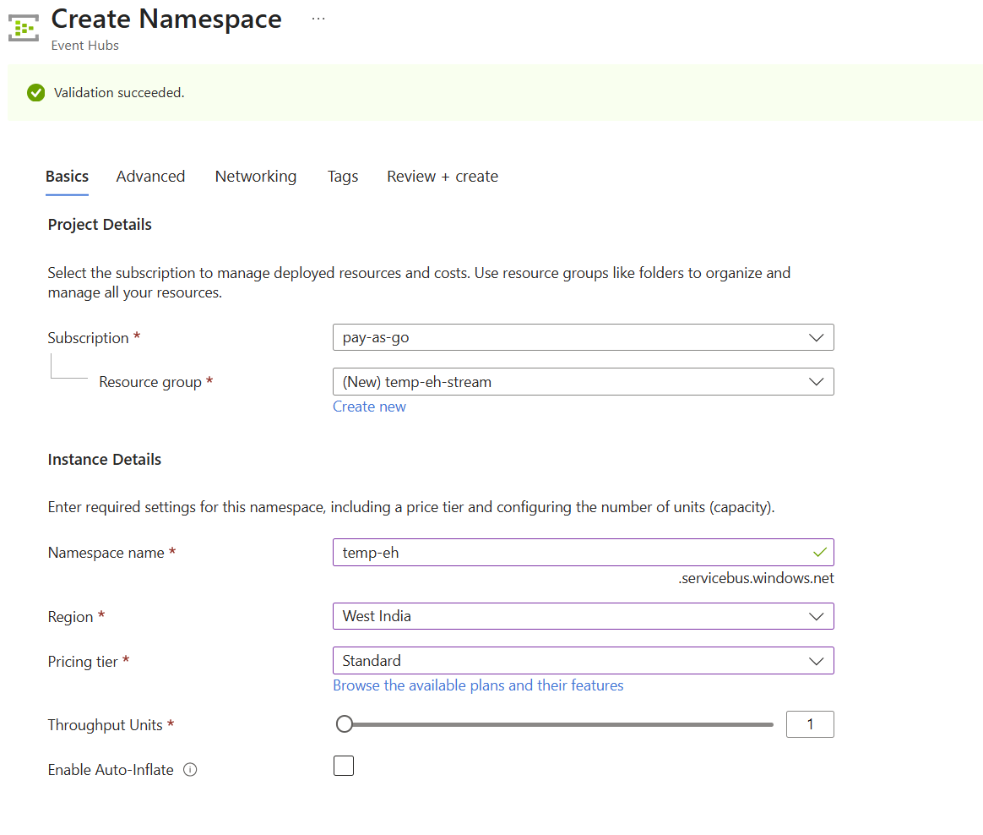
Once deployed successfully go to resource dashboard and create eventhub
- Create event hub
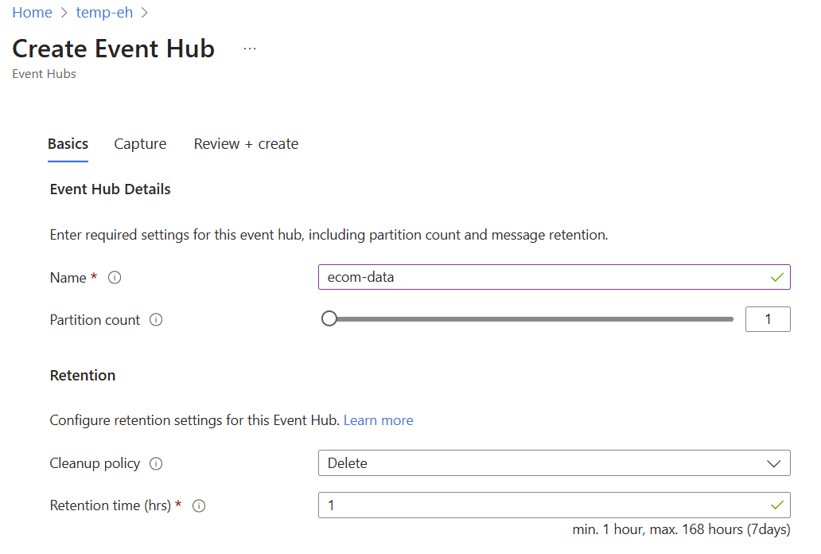
- Add Azure event hub credentials
Host name : overview section
Connection string : settings >> shared access policies >> rootMamangerSharedAccessKey>> Primary connection String
Eventhub name : entities section
# Azure Event Hub credentials
BOOTSTRAP_SERVERS = '<<namespace_host_name>>:9093'
EVENT_HUB_CONNECTION_STRING = '<<namespace_connection_string>>'
EVENT_HUB_NAME = '<<event_hub_name>>'

Add kafka producer function

producer = KafkaProducer(
bootstrap_servers=BOOTSTRAP_SERVERS,
security_protocol='SASL_SSL',
sasl_mechanism='PLAIN',
sasl_plain_username='$ConnectionString',
sasl_plain_password=EVENT_HUB_CONNECTION_STRING,
value_serializer=lambda v: json.dumps(v).encode('utf-8')
)
And finally call producer function in main module
if __name__ == "__main__":
print("Streaming fake U.S. e-commerce orders to Azure Event Hub...")
while True:
event = generate_order()
producer.send(EVENT_HUB_NAME, value=event)
print("Sent:", event)
time.sleep(2)
finally run the new python module and monitor eventhub

PHASE 1 Completed

Phase 2

- Create Databricks workspace as shared cluster will not going to work
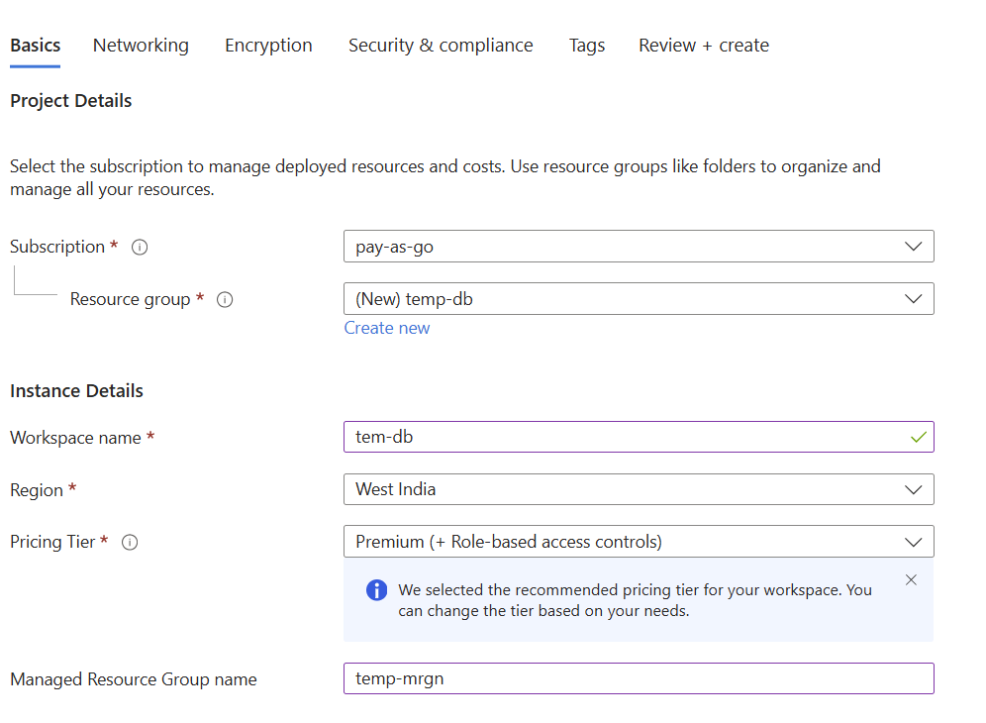
Now let’s create cluster
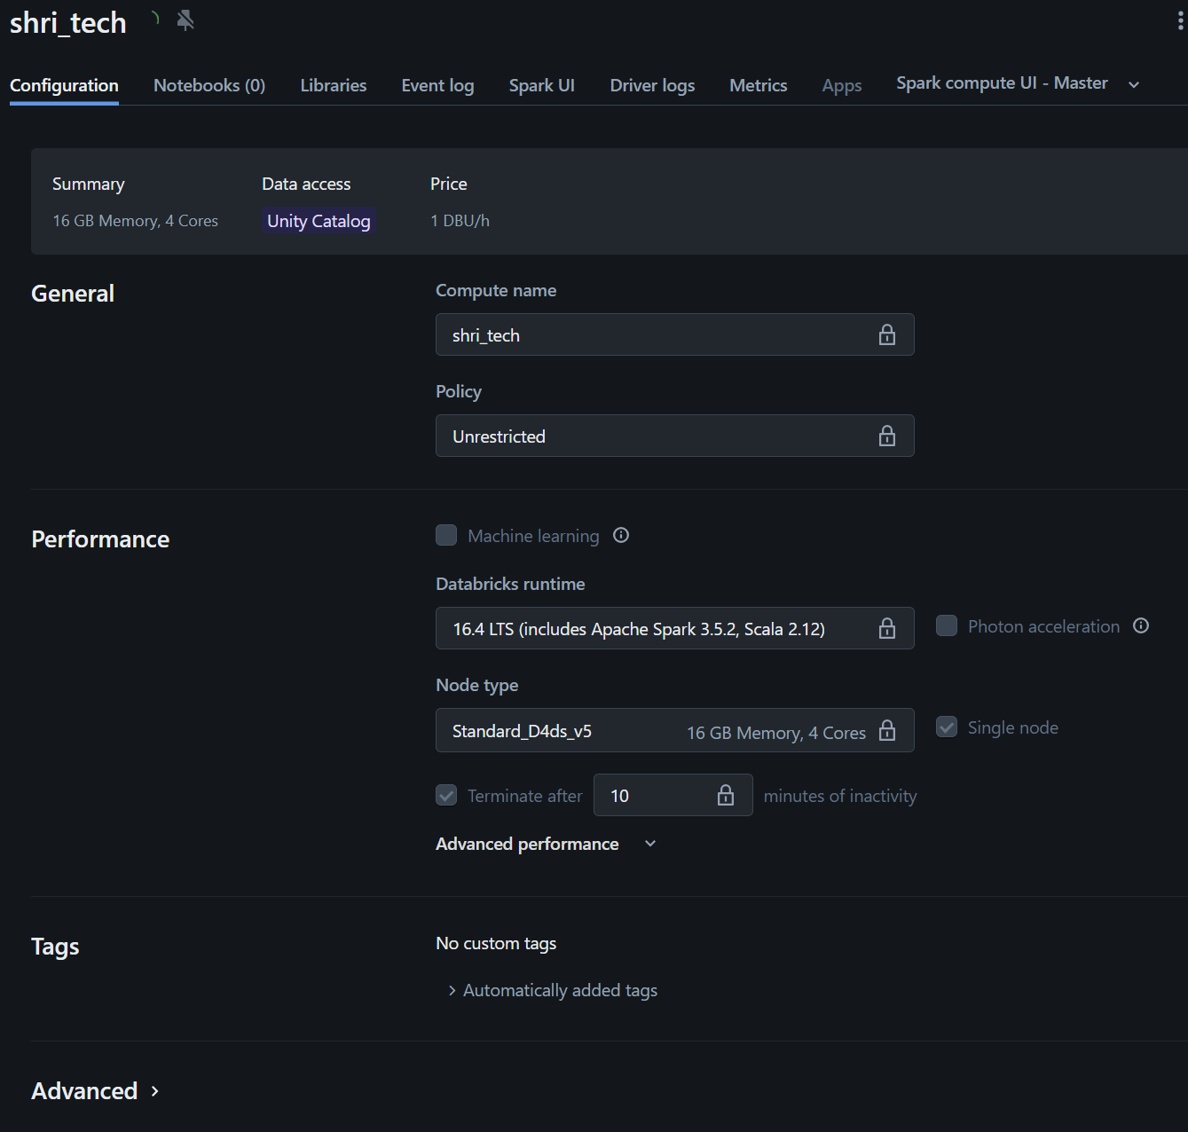

- Now create stream_orders_to_bronze.py
import all required libraries
from pyspark.sql.functions import *
from pyspark.sql.types import *
define storage location and initiate catalog
# Storage location for catalog
# to get storage location got catalog >> settings >> catalog >> external location
storage_location = 'abfss://unity-catalog-storage@dbstorageqcxubpqvntz3o.dfs.core.windows.net/1378876125019939'

# Create Unity Catalog
spark.sql(f"CREATE CATALOG IF NOT EXISTS ecomdata MANAGED LOCATION '{storage_location}'")

# Create bronze layer schema
spark.sql("CREATE SCHEMA IF NOT EXISTS ecomdata.bronze")

# Create silver layer schema
spark.sql("CREATE SCHEMA IF NOT EXISTS ecomdata.silver")

# Create gold layer schema
spark.sql("CREATE SCHEMA IF NOT EXISTS ecomdata.gold")

# Create bronze layer volume for checkpoint
spark.sql("CREATE VOLUME IF NOT EXISTS ecomdata.bronze.bronze_volume")

# Create silver layer volume for checkpoint
spark.sql("CREATE VOLUME IF NOT EXISTS ecomdata.silver.silver_volume")

# Create gold layer volume for checkpoint
spark.sql("CREATE VOLUME IF NOT EXISTS ecomdata.gold.gold_volume")

Kafka datastream will be in binary we need schema to assign this data

#Schema of dataset
schema = StructType([
StructField('order_id',StringType()),
StructField('timestamp',StringType()),
StructField('customer_id',StringType()),
StructField('product_id',StringType()),
StructField('category',StringType()),
StructField('price',DoubleType()),
StructField('quantity',IntegerType()),
StructField('total_amount',DoubleType()),
StructField('city',StringType()),
StructField('state',StringType()),
StructField('country',StringType()),
StructField('latitude',StringType()),
StructField('longitude',StringType()),
StructField('delivery_status',StringType()),
])
Azure event hub configuration
# Azure Event Hub Configuration
event_hub_namespace = "<<NAMESPACE_HOST_NAME>>"
event_hub_name = "<<EVENT_HUB_NAME>>"
event_hub_conn_str = "<<YOUR_EVENT_HUB_CONNECTION_STRING>>"

eh_conf = {
'kafka.bootstrap.servers': f"{event_hub_namespace}:9093",
'subscribe': event_hub_name,
'kafka.security.protocol': 'SASL_SSL',
'kafka.sasl.mechanism': 'PLAIN',
'kafka.sasl.jaas.config': f'kafkashaded.org.apache.kafka.common.security.plain.PlainLoginModule required username="$ConnectionString" password="{event_hub_conn_str}";',
'startingOffsets': 'latest',
'failOnDataLoss': 'false'
}

Now add readstream and write stream method

#Stream from Event Hub
df_raw = (
spark.readStream
.format('kafka')
.options(**eh_conf)
.load()
)

#Parse JSON from kafka stream
df_orders = (
df_raw.selectExpr("Cast(value AS STRING) as json")
.select(from_json("json",schema).alias("data"))
.select("data.*")
)

df_orders.display()

(
df_orders.writeStream
.format('delta')
.outputMode("append")
.option("checkpointLocation","/Volumes/ecomdata/bronze/bronze_volume")
.toTable("ecomdata.bronze.bronze_data")
)

PHASE 2 – Bronze completed
- Create silver layer transformation script
#Imports
from pyspark.sql.functions import *

#configuraions
spark.conf.set(
"fs.azure.account.key.<storage_account>.dfs.core.windows.net",
"<Storage_Account_Access_Key>"
)

bronze_path = "ecomdata.bronze.bronze_data"

silver_path = "ecomdata.silver.silver_data"

#Reading raw data from bronze
df_bronze=spark.readStream\
.format("delta")\
.table(bronze_path)

#Clean and enrich
df_clean=(
df_bronze
.withColumn("timestamp",to_timestamp("timestamp"))
.withColumn("price",when(col("price").isNull(),0.0).otherwise(col("price")))
.withColumn("quantity",when(col("quantity").isNull(),1).otherwise(col("quantity")))
.withColumn("total_amount",col("price")*col("quantity"))
.dropDuplicates(["order_id"])
.filter(col("country")=="IND")
.filter(col("state").isNotNull())
)
#Write to Silver Layer

df_clean.writeStream\
.option("checkpointLocation","/Volumes/ecomdata/silver/silver_volume")\
.outputMode("append")\
.format("delta")\
.toTable(silver_path)

PHASE 2 – Silver completed

- Now lets create final gold layer
As we don’t have much data so will aggregate on 1 minute otherwise typically we aggregate hourly basis

from pyspark.sql.functions import *
silver_path = "ecomdata.silver.silver_data"
gold_path = "ecomdata.gold.gold_data"
#Read from silver
df_silver=spark.readStream\
.format("delta")\
.load(silver_path)

#Aggregation: Total sales and total items sold per state per minute
df_gold=(
df_silver
.withWatermark("timestamp","1 minute")
.groupby(
window("timestamp","1 minute"),
"state"
)
.agg(
sum("total_amount").alias("total_sales"),
sum("quantity").alias("total_items")
)
.select(
col("window.start").alias("window_start"),
col("window.end").alias("window_end"),
"state",
"total_sales",
"total_items"
)
)

# Write to gold layer

df_gold.writeStream\
.format("delta")\
.outputMode("append")\
.option("checkpointLocation","/Volumes/ecomdata/gold/gold_volume")\
.toTable(gold_path)

Finally show all table with read table command

df_bronze = spark.read.table("ecomdata.bronze.bronze_data")
df_bronze.display()

PHASE 2 Completed

PHASE 3
Create data warehouse
%sql
CREATE OR REPLACE TABLE default.gold_order_managed
AS SELECT * FROM ecomdata.gold.gold_data

Check in sample data or just run simple query in SQL Editor

select * from gold_order_managed limit 10

- open The Powerbi desktop
- click on connect other data sources
- select azure databricks and select azure active directory
- select dataset and now we are ready to create dashboard
Here we finish the DE job

- Go to marketplace
- Click on powerbi
- Select the compute and click on download connection file
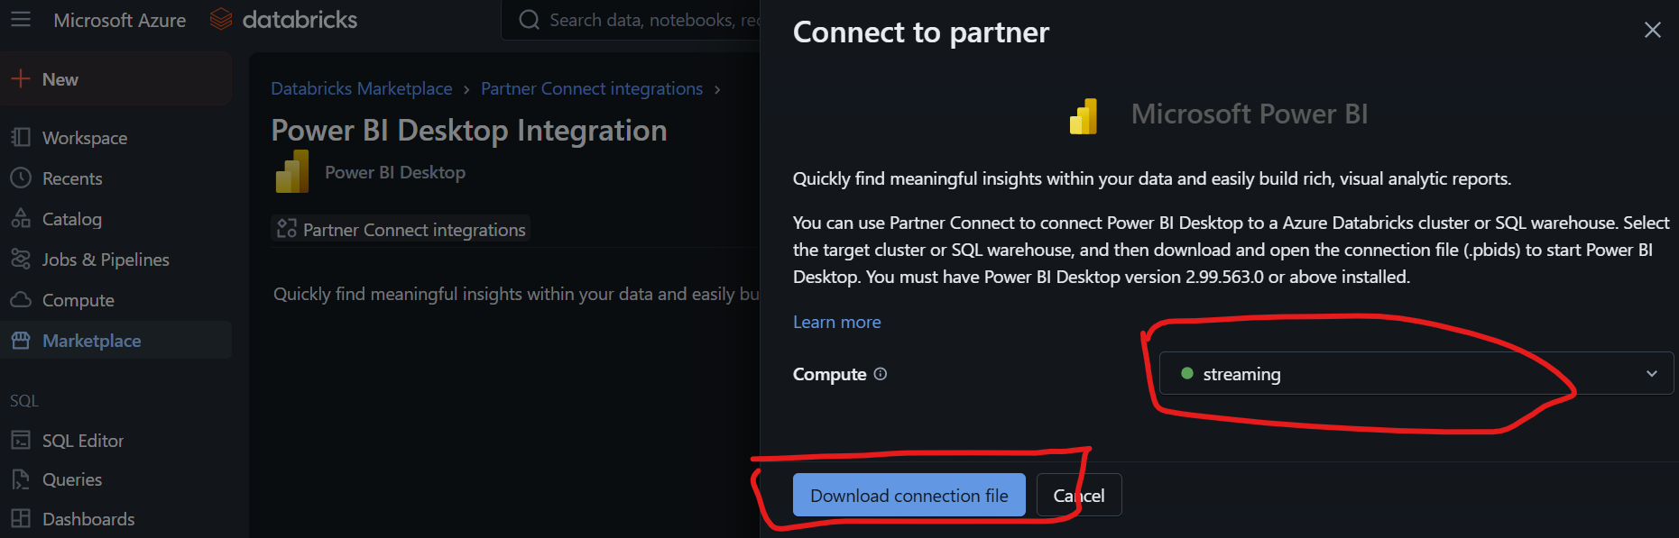

- Now open the powerbi file in power bi desktop and select azure active directory
- Vfaln
- Sav
- asvkj

